# **Name: Abdurrahman Qureshi**

# **Roll No: 242466**

Practical No: 4

Date Of Performance: 29/01/2024

Aim: To install and configure the NS2 simulator on Windows 10 using Ubuntu on WSL (Windows Subsystem for Linux), and to create and run a basic simulation script to demonstrate its functionality.

Lab Objectives:

To setup and visualize different network topologies via NS2, including Bus, Ring, and Star. The objective is to understand the structure and behavior of these topologies, analyze packet flow, and evaluate performance metrics such as delay and throughput.

Lab Outcomes:

Successfully created and simulated Bus, Ring, and Star topologies in NS2. The simulation allowed for an in-depth analysis of network behavior, including packet transmission efficiency, node connectivity, and data collision scenarios. The results provide insights into the advantages and limitations of each topology for different network applications.

RING TOPOLOGY:

CODE:

# Create global variables

set ns [new Simulator]

# Set nam trace

set namf [open ring.nam w]

$ns namtrace-all $namf

# Open the trace file

set tracef [open ring.tr w]

$ns trace-all $tracef

# Creating nodes

set n0 [$ns node]

set n1 [$ns node]

set n2 [$ns node]

set n3 [$ns node]

set n4 [$ns node]

set n5 [$ns node]

# Establish links (Ring topology - closed loop)

$ns duplex-link $n0 $n1 3Mb 3ms DropTail

$ns duplex-link $n1 $n2 3Mb 3ms DropTail

$ns duplex-link $n2 $n3 3Mb 3ms DropTail

$ns duplex-link $n3 $n4 3Mb 3ms DropTail

$ns duplex-link $n4 $n5 3Mb 3ms DropTail

$ns duplex-link $n5 $n0 3Mb 3ms DropTail

# Label nodes

$ns at 0.0 "$n0 label Node1"

$ns at 0.0 "$n1 label Node2"

$ns at 0.0 "$n2 label Node3"

$ns at 0.0 "$n3 label Node4"

$ns at 0.0 "$n4 label Node5"

$ns at 0.0 "$n5 label Node6"

# Node colors

$n0 color blue

$n1 color red

$n2 color green

$n3 color yellow

$n4 color white

$n5 color green

# Procedure to finish simulation

proc finish {} {

global ns tracef namf

$ns flush-trace

close $tracef

close $namf

exec nam ring.nam &

exit 0

}

# Schedule finish procedure

$ns at 5.0 "finish"

$ns run

OUTPUT:

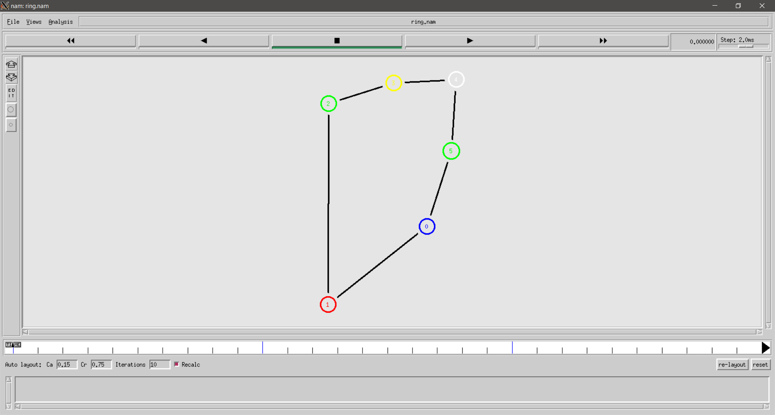

STAR TOPOLOGY:

CODE:

# Create global variables

set ns [new Simulator]

# Set nam trace

set namf [open star.nam w]

$ns namtrace-all $namf

# Open the trace file

set tracef [open star.tr w]

$ns trace-all $tracef

# Creating nodes

set central [$ns node]

set n1 [$ns node]

set n2 [$ns node]

set n3 [$ns node]

set n4 [$ns node]

set n5 [$ns node]

set n6 [$ns node]

# Establish links (Star topology - all connect to central node)

$ns duplex-link $central $n1 2Mb 10ms DropTail

$ns duplex-link $central $n2 2Mb 10ms DropTail

$ns duplex-link $central $n3 2Mb 10ms DropTail

$ns duplex-link $central $n4 2Mb 10ms DropTail

$ns duplex-link $central $n5 2Mb 10ms DropTail

$ns duplex-link $central $n6 2Mb 10ms DropTail

# Label nodes

# $ns at 0.0 "$central label Central Switch"

$ns at 0.0 "$n1 label Host1"

$ns at 0.0 "$n2 label Host2"

$ns at 0.0 "$n3 label Host3"

$ns at 0.0 "$n3 label Host4"

$ns at 0.0 "$n3 label Host5"

$ns at 0.0 "$n3 label Host6"

# Node colors

$central color red

$n1 color blue

$n2 color green

$n3 color yellow

$n4 color blue

$n5 color green

$n6 color yellow

# Procedure to finish simulation

proc finish {} {

global ns tracef namf

$ns flush-trace

close $tracef

close $namf

exec nam star.nam &

exit 0

}

# Schedule finish procedure

$ns at 5.0 "finish"

$ns run

OUTPUT:

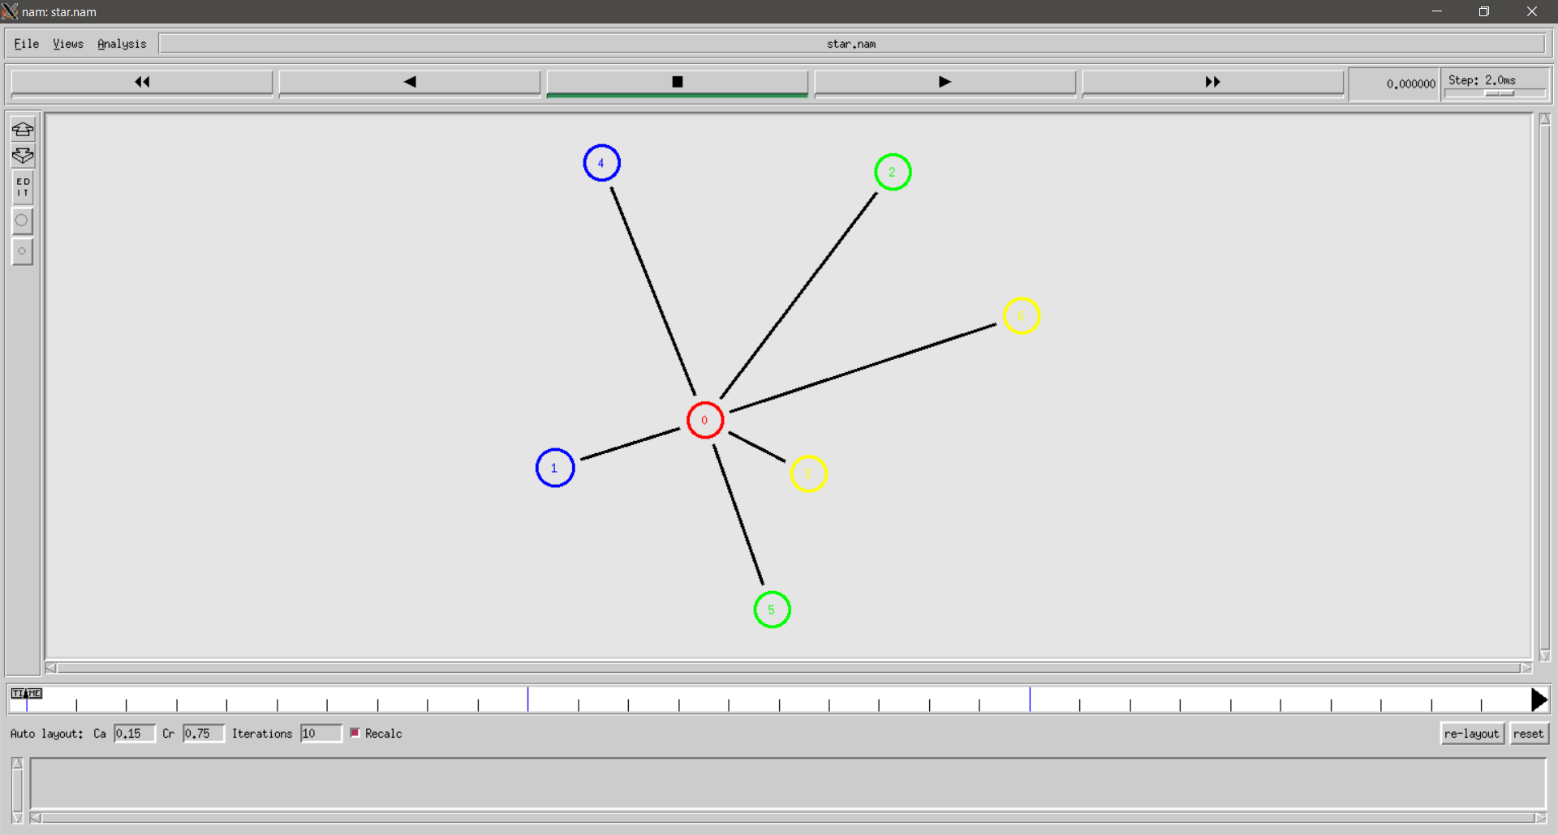

BUS TOPOLOGY:

CODE:

# Create global variables

set ns [new Simulator]

# Set nam trace

set namf [open bus.nam w]

$ns namtrace-all $namf

# Open the trace file

set tracef [open bus.tr w]

$ns trace-all $tracef

# Creating nodes

set nA [$ns node]

set n1 [$ns node]

set n2 [$ns node]

set n3 [$ns node]

set n4 [$ns node]

set nZ [$ns node]

# Establish links (Bus topology - all connected in a single line)

$ns duplex-link $nA $nZ 2Mb 10ms DropTail

$ns duplex-link $n1 $n2 2Mb 10ms DropTail

$ns duplex-link $n3 $n4 2Mb 10ms DropTail

# Label nodes

$ns at 0.0 "$nA label Host1"

$ns at 0.0 "$n1 label Switch"

$ns at 0.0 "$n2 label Host2"

$ns at 0.0 "$n3 label Switch"

$ns at 0.0 "$n4 label Host2"

$ns at 0.0 "$nZ label Host3"

# Node colors

$nA color blue

$n1 color red

$n2 color green

$n3 color red

$n4 color green

$nZ color yellow

# Procedure to finish simulation

proc finish {} {

global ns tracef namf

$ns flush-trace

close $tracef

close $namf

exec nam bus.nam &

exit 0

}

# Schedule finish procedure

$ns at 5.0 "finish"

$ns run

OUTPUT:

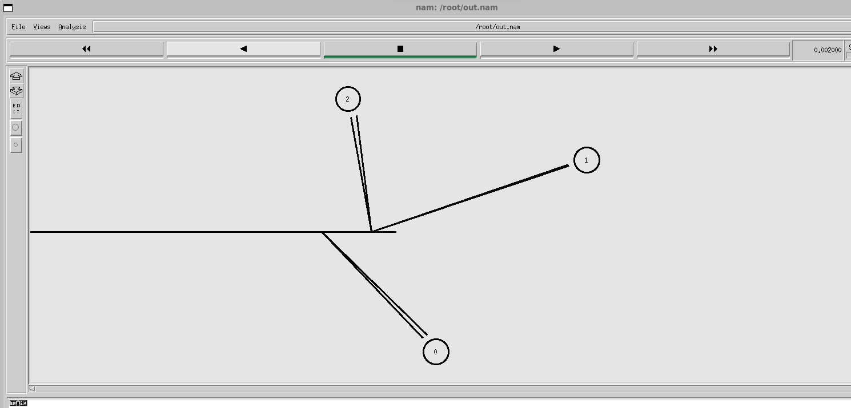

Conclusion:

We set up NS2 on Windows 10 via Ubuntu on WSL and simulated Bus, Ring, and Star topologies. This enabled us to analyze performance metrics, packet flow, and topology behavior, enhancing our understanding of network simulation and NS2’s role in performance evaluation.

|  |  |  |  |  |  |
| --- | --- | --- | --- | --- | --- |
| Performance  (7M) | Journal  (3M) | Lab Ethics  (2M) | Attendance  (3M) | Total  (15M) | Faculty Signature |
|  |  |  |  |  |  |